

**PEACE CORPS**

Overseas Request for Quotation (RFQ) for Conference Services.

RFQ Number: **PTU-25-29**

Date: **October 23, 2024**

Peace Corps/Kyrgyz Republic has a need for conference services**:**

1. Event #1: February 18-20, 2025. Bishkek
2. Event #2: May 6-7, 2025. Bishkek or Yssyk-Kul (preferable)
3. Event #3: June 9-13, 2025. Bishkek or surrounding areas
4. Event #4: September 23-25, 2025. Bishkek
5. Event #5: March 10-28, 2025. Bishkek

**Peace Corps/Kyrgyz Republic works directly with hotels but not the intermediary companies to organize conferences.**

Peace Corps is soliciting fixed-price quotations from the vendor community for the services detailed below.

If you are interested in submitting a quotation, please do so by sending your completed and signed Attachment 1—Vendor Quotation Form for **each event** by e-mail to:

Name: Contracting Officer

Address: 304 Chokmorov Street, Bishkek city

E-mail: [pckg.contracting@gmail.com](mailto:pckg.contracting@gmail.com)

Quotations are due on **November 21, 2024.** Late quotations will not be accepted.

**You can submit a proposal for one or several events at once.**

Written questions about this Request for Quotation (RFQ) may be sent in the same fashion to the individual noted above in advance of the RFQ due date.

Peace Corps will evaluate all quotations received by the deadline based on the requirements shown below. Contingent on the availability of funds and continued need for the supplies and/or services, at the end of the evaluation process, Peace Corps intends to award a firm-fixed-price contract for the purchase of the required services to the selected vendor.

1. **Description of Requirements**

**Event #1: in Bishkek city.**

**Event #2: in Bishkek city or Issyk-Kul (preferable).**

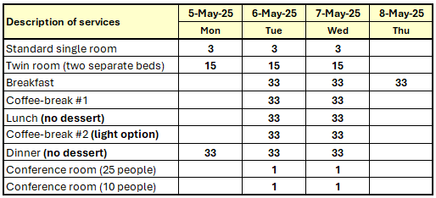

**Event #3: Bishkek or Surrounding areas.**



**Event #4: in Bishkek city.**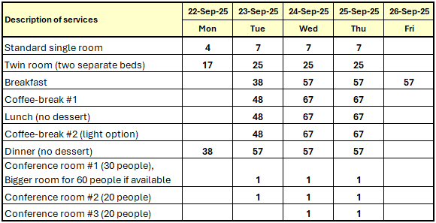

**Event #5: in Bishkek city.**

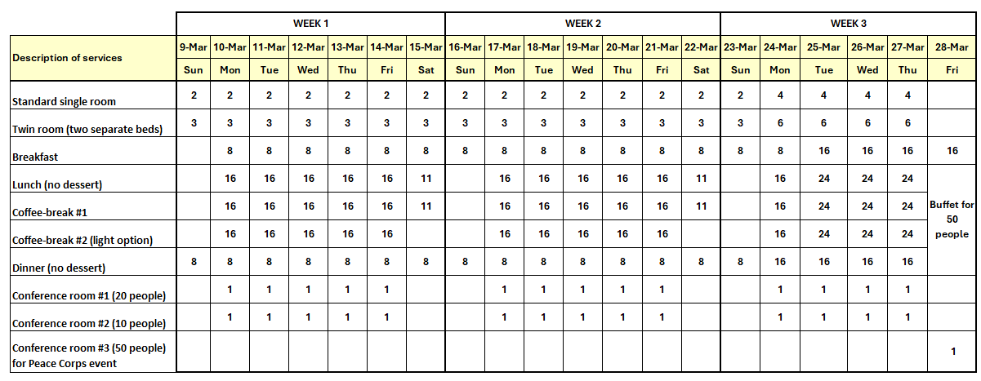

All Quotes shall be in **Kyrgyz soms**, and inclusive of any taxes, fees and administrative or overhead costs. Payment to the vendor for conference services can be made via Electronic Funds Transfer (EFT) to their bank account within 20 working days after acceptance and receipt of valid invoice. Payment can also be made by credit card VISA.

**B.** **Contract Terms and Conditions**

As an Agency of the United States Government, Peace Corps has an approved contract template that it intends to use for the award. Peace Corps reserves the right to deny making a contract award to a vendor should they refuse to sign the Peace Corps approved contract template.

**C. Minimum Criteria:**

A quotation will not be considered further if it does not meet the following minimum criteria:

* Confirms that hotel has capacity to host up to required number of guests with sufficient single and twin rooms with separate beds.
* Has the required number of conference/training rooms for all participants.
* Property is in adequate condition and located in the area bounded by the following streets:
* North: to and along Jibek Jolu Ave.
* West: to and along Fuchik Street
* East: to and along Almatinskaya/April 7th Street
* South: to and along Yujnaya Magistral
* Has easy access to the hotel for guests and cars.
* Either no feedback was received on property (neutral past performance rating) or the feedback that was received contained more positive than negative information.

**D. Evaluation Factors:**

Quotations that meet the minimum criteria listed above may be further evaluated based on the following factors:

* Quality of Facilities
* Compliance with all safety standards
* Past Performance

Award may be made with or without negotiations between the Peace Corps and the selected vendor. Award may be made to a vendor that provided the lowest priced technically acceptable quotation, or to a vendor other than the one that provided the lowest priced quotation, should that vendor be determined to have provided the best value quotation to the Peace Corps taking technical and cost factors into account.

**Decisions will be made based on the results of physical inspections of the hotel's compliance with the Peace Corps criteria outlined above.**

All vendors that submit quotations in response to this RFQ will be notified of the results.

[End of RFQ]

**ATTACHMENT 1 – VENDOR QUOTATION FORM:**

RFQ Number: **PTU-25-29**

**EVENT #1**

Vendor Name: ___________________________

Quoted Prices (in Kyrgyz Soms) (Inclusive of Administrative and/or Overhead Costs):

|  |  |  |  |  |  |  |  |  |  |  |  |  |
| --- | --- | --- | --- | --- | --- | --- | --- | --- | --- | --- | --- | --- |
| **Description of services** | **Unit price in Soms** | **17-Feb-25** | | **18-Feb-25** | | **19-Feb-25** | | **20-Feb-25** | | **21-Feb-25** | | **Total Sum** |
| **Unit** | **Sum** | **Unit** | **Sum** | **Unit** | **Sum** | **Unit** | **Sum** | **Unit** | **Sum** |
| Standard single room |  | **3** |  | **3** |  | **3** |  | **3** |  |  |  |  |
| Twin room (two separate beds) |  | **27** |  | **27** |  | **27** |  | **27** |  |  |  |  |
| Breakfast |  |  |  | **57** |  | **57** |  | **57** |  | **57** |  |  |
| Coffee-break #1 |  |  |  | **67** |  | **67** |  | **67** |  |  |  |  |
| Lunch (no dessert) |  |  |  | **67** |  | **67** |  | **67** |  |  |  |  |
| Coffee-break #2 (light option) |  |  |  | **67** |  | **67** |  | **67** |  |  |  |  |
| Dinner (no dessert) |  | **57** |  | **57** |  | **57** |  | **57** |  |  |  |  |
| Conference room #1 (30 people) |  |  |  | **1** |  | **1** |  | **1** |  |  |  |  |
| Conference room #2 (20 people) |  |  |  | **1** |  | **1** |  | **1** |  |  |  |  |
| Conference room #3 (20 people) |  |  |  | **1** |  | **1** |  | **1** |  |  |  |  |
| **Total** | | |  |  |  |  |  |  |  |  |  |  |

Items/Services Included in Total Quoted Price Above but Not Indicated in Chart (if any):

**SUPPLIER AUTHORIZED REPSENTATIVE**

Signature: _______________________________

Date: _______________________________

RFQ Number: **PTU-25-29**

**EVENT #2**

Vendor Name: ___________________________

Quoted Prices (in Kyrgyz Soms) (Inclusive of Administrative and/or Overhead Costs):

|  |  |  |  |  |  |  |  |  |  |  |
| --- | --- | --- | --- | --- | --- | --- | --- | --- | --- | --- |
| **Description of services** | **Unit price in Soms** | **5-May-25** | | **6-May-25** | | **7-May-25** | | **8-May-25** | | **Total Sum** |
| **Unit** | **Sum** | **Unit** | **Sum** | **Unit** | **Sum** | **Unit** | **Sum** |
| Standard single room |  | **3** |  | **3** |  | **3** |  |  |  |  |
| Twin room (two separate beds) |  | **15** |  | **15** |  | **15** |  |  |  |  |
| Breakfast |  |  |  | **33** |  | **33** |  | **33** |  |  |
| Lunch |  |  |  | **33** |  | **33** |  |  |  |  |
| Coffee-break #1 |  |  |  | **33** |  | **33** |  |  |  |  |
| Coffee-break #2 |  |  |  | **33** |  | **33** |  |  |  |  |
| Dinner |  | **33** |  | **33** |  | **33** |  |  |  |  |
| Conference room (25 people) |  |  |  | **1** |  | **1** |  |  |  |  |
| Conference room (10 people) |  |  |  | **1** |  | **1** |  |  |  |  |
| **Total** | | |  |  |  |  |  |  |  |  |

Items/Services Included in Total Quoted Price Above but Not Indicated in Chart (if any):

**SUPPLIER AUTHORIZED REPSENTATIVE**

Signature: _______________________________

Date: _______________________________

RFQ Number: **PTU-25-29**

**EVENT #3**

Vendor Name: ___________________________

Quoted Prices (in Kyrgyz Soms) (Inclusive of Administrative and/or Overhead Costs):

|  |  |  |  |  |  |  |  |  |  |  |  |  |  |  |  |  |
| --- | --- | --- | --- | --- | --- | --- | --- | --- | --- | --- | --- | --- | --- | --- | --- | --- |
| **Description of services** | **Unit price in Soms** | **8-Jun-25** | | **9-Jun-25** | | **10-Jun-25** | | **11-Jun-25** | | **12-Jun-25** | | **13-Jun-25** | | **14-Jun-25** | | **Total Sum** |
| **Unit** | **Sum** | **Unit** | **Sum** | **Unit** | **Sum** | **Unit** | **Sum** | **Unit** | **Sum** | **Unit** | **Sum** | **Unit** | **Sum** |
| Standard single room |  | **10** |  | **10** |  | **10** |  | **10** |  | **10** |  | **10** |  |  |  |  |
| Twin room (two separate beds) |  | **21** |  | **21** |  | **21** |  | **21** |  | **21** |  | **21** |  |  |  |  |
| Breakfast |  |  |  | **52** |  | **52** |  | **52** |  | **52** |  | **52** |  | **52** |  |  |
| Lunch |  |  |  | **52** |  | **52** |  | **52** |  | **52** |  | **52** |  |  |  |  |
| Coffee-break #1 |  |  |  | **52** |  | **52** |  | **52** |  | **52** |  | **52** |  |  |  |  |
| Coffee-break #2 |  |  |  | **52** |  | **52** |  | **52** |  | **52** |  | **52** |  |  |  |  |
| Dinner |  |  |  | **52** |  | **52** |  | **52** |  | **52** |  | **52** |  |  |  |  |
| Conf. room #1 (40 people capacity) |  |  |  | **1** |  | **1** |  | **1** |  | **1** |  | **1** |  |  |  |  |
| Conf. room #2 (15 people capacity ) |  |  |  | **1** |  | **1** |  | **1** |  | **1** |  | **1** |  |  |  |  |
| Conf. room #3 (10 people capacity) |  |  |  | **1** |  | **1** |  | **1** |  | **1** |  | **1** |  |  |  |  |
| Single room for Medical team |  |  |  | **2** |  | **2** |  | **2** |  | **2** |  | **2** |  |  |  |  |
| **Total** | | |  |  |  |  |  |  |  |  |  |  |  |  |  |  |

Items/Services Included in Total Quoted Price Above but Not Indicated in Chart (if any):

**SUPPLIER AUTHORIZED REPSENTATIVE**

Signature: _______________________________

Date: _______________________________

RFQ Number: **PTU-25-29**

**EVENT #4**

Vendor Name: ___________________________

Quoted Prices (in Kyrgyz Soms) (Inclusive of Administrative and/or Overhead Costs):

|  |  |  |  |  |  |  |  |  |  |  |  |  |
| --- | --- | --- | --- | --- | --- | --- | --- | --- | --- | --- | --- | --- |
| **Description of services** | **Unit price in Soms** | **22-Sep-25** | | **23-Sep-25** | | **24-Sep-25** | | **25-Sep-25** | | **26-Sep-25** | | **Total Sum** |
| **Unit** | **Sum** | **Unit** | **Sum** | **Unit** | **Sum** | **Unit** | **Sum** | **Unit** | **Sum** |
| Standard single room |  | **4** |  | **7** |  | **7** |  | **7** |  |  |  |  |
| Twin room (two separate beds) |  | **17** |  | **25** |  | **25** |  | **25** |  |  |  |  |
| Breakfast |  |  |  | **38** |  | **57** |  | **57** |  | **57** |  |  |
| Coffee-break #1 |  |  |  | **48** |  | **67** |  | **67** |  |  |  |  |
| Lunch |  |  |  | **48** |  | **67** |  | **67** |  |  |  |  |
| Coffee-break #2 |  |  |  | **48** |  | **67** |  | **67** |  |  |  |  |
| Dinner |  | **38** |  | **57** |  | **57** |  | **57** |  |  |  |  |
| Conference room #1 (30 people) |  |  |  | **1** |  | **1** |  | **1** |  |  |  |  |
| Conference room #2 (20 people) |  |  |  | **1** |  | **1** |  | **1** |  |  |  |  |
| Conference room #3 (20 people) |  |  |  |  |  | **1** |  | **1** |  |  |  |  |
| **Total** | | |  |  |  |  |  |  |  |  |  |  |

Items/Services Included in Total Quoted Price Above but Not Indicated in Chart (if any):

**SUPPLIER AUTHORIZED REPSENTATIVE**

Signature: _______________________________

Date: _______________________________

RFQ Number: **PTU-25-29**

**EVENT #5**

Vendor Name: ___________________________

Quoted Prices (in Kyrgyz Soms) (Inclusive of Administrative and/or Overhead Costs):

|  |  |  |  |  |  |  |  |  |  |  |  |  |  |  |  |  |
| --- | --- | --- | --- | --- | --- | --- | --- | --- | --- | --- | --- | --- | --- | --- | --- | --- |
| **Week 1** |  |  |  |  |  |  |  |  |  |  |  |  |  |  |  |  |
| **Description of services** | **Unit price in Soms** | **9-Mar-25** | | **10-Mar-25** | | **11-Mar-25** | | **12-Mar-25** | | **13-Mar-25** | | **14-Mar-25** | | **15-Mar-25** | | **Total Sum Week 1** |
| **Unit** | **Sum** | **Unit** | **Sum** | **Unit** | **Sum** | **Unit** | **Sum** | **Unit** | **Sum** | **Unit** | **Sum** | **Unit** | **Sum** |
| Standard single room |  | **2** |  | **2** |  | **2** |  | **2** |  | **2** |  | **2** |  | **2** |  |  |
| Twin room (two separate beds) |  | **3** |  | **3** |  | **3** |  | **3** |  | **3** |  | **3** |  | **3** |  |  |
| Breakfast |  |  |  | **8** |  | **8** |  | **8** |  | **8** |  | **8** |  | **8** |  |  |
| Lunch |  |  |  | **16** |  | **16** |  | **16** |  | **16** |  | **16** |  | **11** |  |  |
| Coffee-break #1 |  |  |  | **16** |  | **16** |  | **16** |  | **16** |  | **16** |  | **11** |  |  |
| Coffee-break #2 |  |  |  | **16** |  | **16** |  | **16** |  | **16** |  | **16** |  |  |  |  |
| Dinner |  | **8** |  | **8** |  | **8** |  | **8** |  | **8** |  | **8** |  | **8** |  |  |
| Conference room #1 (20 people) |  |  |  | **1** |  | **1** |  | **1** |  | **1** |  | **1** |  |  |  |  |
| Conference room #2 (10 people) |  |  |  | **1** |  | **1** |  | **1** |  | **1** |  | **1** |  |  |  |  |
| **Total** | | |  |  |  |  |  |  |  |  |  |  |  |  |  |  |

|  |  |  |  |  |  |  |  |  |  |  |  |  |  |  |  |  |
| --- | --- | --- | --- | --- | --- | --- | --- | --- | --- | --- | --- | --- | --- | --- | --- | --- |
| **Week 2** |  |  |  |  |  |  |  |  |  |  |  |  |  |  |  |  |
| **Description of services** | **Unit price in Soms** | **16-Mar-25** | | **17-Mar-25** | | **18-Mar-25** | | **19-Mar-25** | | **20-Mar-25** | | **21-Mar-25** | | **22-Mar-25** | | **Total Sum Week 2** |
| **Unit** | **Sum** | **Unit** | **Sum** | **Unit** | **Sum** | **Unit** | **Sum** | **Unit** | **Sum** | **Unit** | **Sum** | **Unit** | **Sum** |
| Standard single room |  | **2** |  | **2** |  | **2** |  | **2** |  | **2** |  | **2** |  | **2** |  |  |
| Twin room (two separate beds) |  | **3** |  | **3** |  | **3** |  | **3** |  | **3** |  | **3** |  | **3** |  |  |
| Breakfast |  |  |  | **8** |  | **8** |  | **8** |  | **8** |  | **8** |  | **8** |  |  |
| Lunch |  |  |  | **16** |  | **16** |  | **16** |  | **16** |  | **16** |  | **11** |  |  |
| Coffee-break #1 |  |  |  | **16** |  | **16** |  | **16** |  | **16** |  | **16** |  | **11** |  |  |
| Coffee-break #2 |  |  |  | **16** |  | **16** |  | **16** |  | **16** |  | **16** |  |  |  |  |
| Dinner |  | **8** |  | **8** |  | **8** |  | **8** |  | **8** |  | **8** |  | **8** |  |  |
| Conference room #1 (20 people) |  |  |  | **1** |  | **1** |  | **1** |  | **1** |  | **1** |  |  |  |  |
| Conference room #2 (10 people) |  |  |  | **1** |  | **1** |  | **1** |  | **1** |  | **1** |  |  |  |  |
| **Total** |  |  |  |  |  |  |  |  |  |  |  |  |  |  |  |  |

|  |  |  |  |  |  |  |  |  |  |  |  |  |  |  |
| --- | --- | --- | --- | --- | --- | --- | --- | --- | --- | --- | --- | --- | --- | --- |
| **Week 3** |  |  |  |  |  |  |  |  |  |  |  |  |  |  |
| **Description of services** | **Unit price in Soms** | **23-Mar-25** | | **24-Mar-25** | | **25-Mar-25** | | **26-Mar-25** | | **27-Mar-25** | | **28-Mar-25** | | **Total Sum Week 3** |
|  | **Unit** | **Sum** | **Unit** | **Sum** | **Unit** | **Sum** | **Unit** | **Sum** | **Unit** | **Sum** | **Unit** | **Sum** |
| Standard single room |  | **2** |  | **4** |  | **4** |  | **4** |  | **4** |  |  |  |  |
| Twin room (two separate beds) |  | **3** |  | **6** |  | **6** |  | **6** |  | **6** |  |  |  |  |
| Breakfast |  | **8** |  | **8** |  | **16** |  | **16** |  | **16** |  | **16** |  |  |
| Lunch |  |  |  | **16** |  | **24** |  | **24** |  | **24** |  | **Buffet for  50 people** |  |  |
| Coffee-break #1 |  |  |  | **16** |  | **24** |  | **24** |  | **24** |  |  |
| Coffee-break #2 |  |  |  | **16** |  | **24** |  | **24** |  | **24** |  |  |
| Dinner |  | **8** |  | **16** |  | **16** |  | **16** |  | **16** |  |  |
| Conference room #1 (20 people) |  |  |  | **1** |  | **1** |  | **1** |  | **1** |  |  |  |  |
| Conference room #2 (10 people) |  |  |  | **1** |  | **1** |  | **1** |  | **1** |  |  |  |  |
| Conference room #3 (50 people)  for Peace Corps event |  |  |  |  |  |  |  |  |  |  |  | **1** |  |  |
| **Total** |  |  |  |  |  |  |  |  |  |  |  |  |  |  |

**Grand Total**

|  |  |
| --- | --- |
| **Description of services** | **Total Week 1 and Week 3** |
| Standard single room |  |
| Twin room (two separate beds) |  |
| Breakfast |  |
| Lunch |  |
| Coffee-break #1 |  |
| Coffee-break #2 |  |
| Dinner |  |
| Conference room #1 (20 people) |  |
| Conference room #2 (10 people) |  |
| Conference room #3 (50 people) for Peace Corps event |  |
| **Grand Total** |  |

Items/Services Included in Total Quoted Price Above but Not Indicated in Chart (if any):

**SUPPLIER AUTHORIZED REPSENTATIVE**

Signature: _______________________________

Date: _______________________________